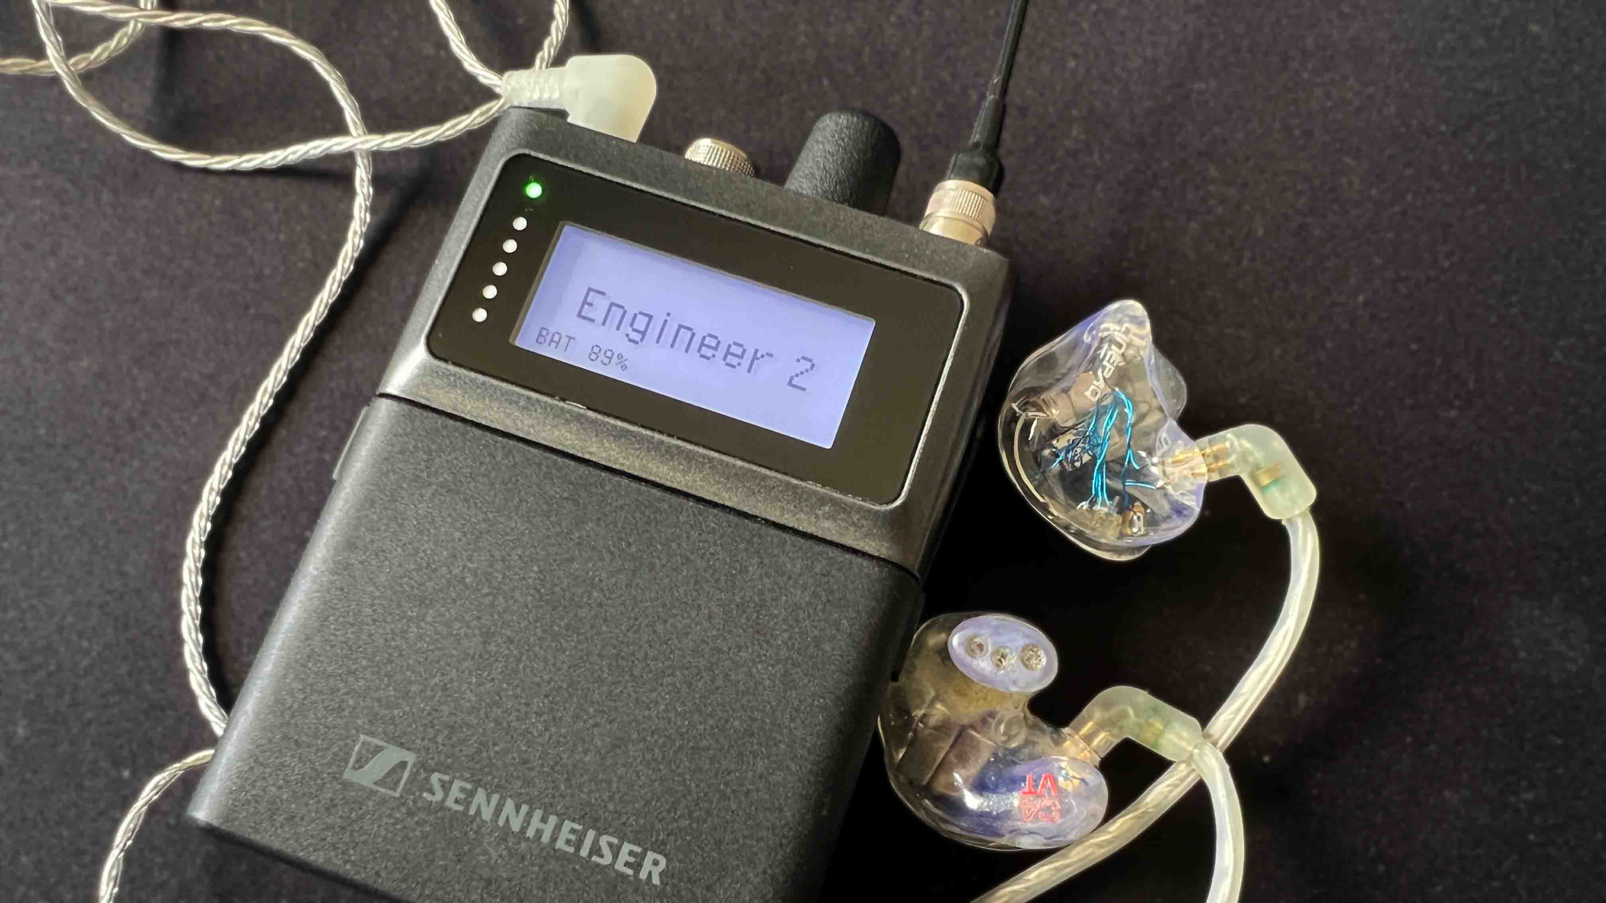

Sennheiser Spectera module now available in Bitfocus Companion and Buttons apps
Integration opens up many new features for Spectera users

Wedemark, April 19, 2026 — A Sennheiser Spectera module is now available in the Bitfocus apps Companion and Buttons, expanding Spectera features for engineers and technicians. With the module, they can implement an engineer mode for Spectera or facilitate quick instrument swaps, for example. The Spectera module allows direct connection and drop integration of Spectera with the two Bitfocus software platforms, joining around a thousand modules from major manufacturers in the fields of audio, video and lighting.

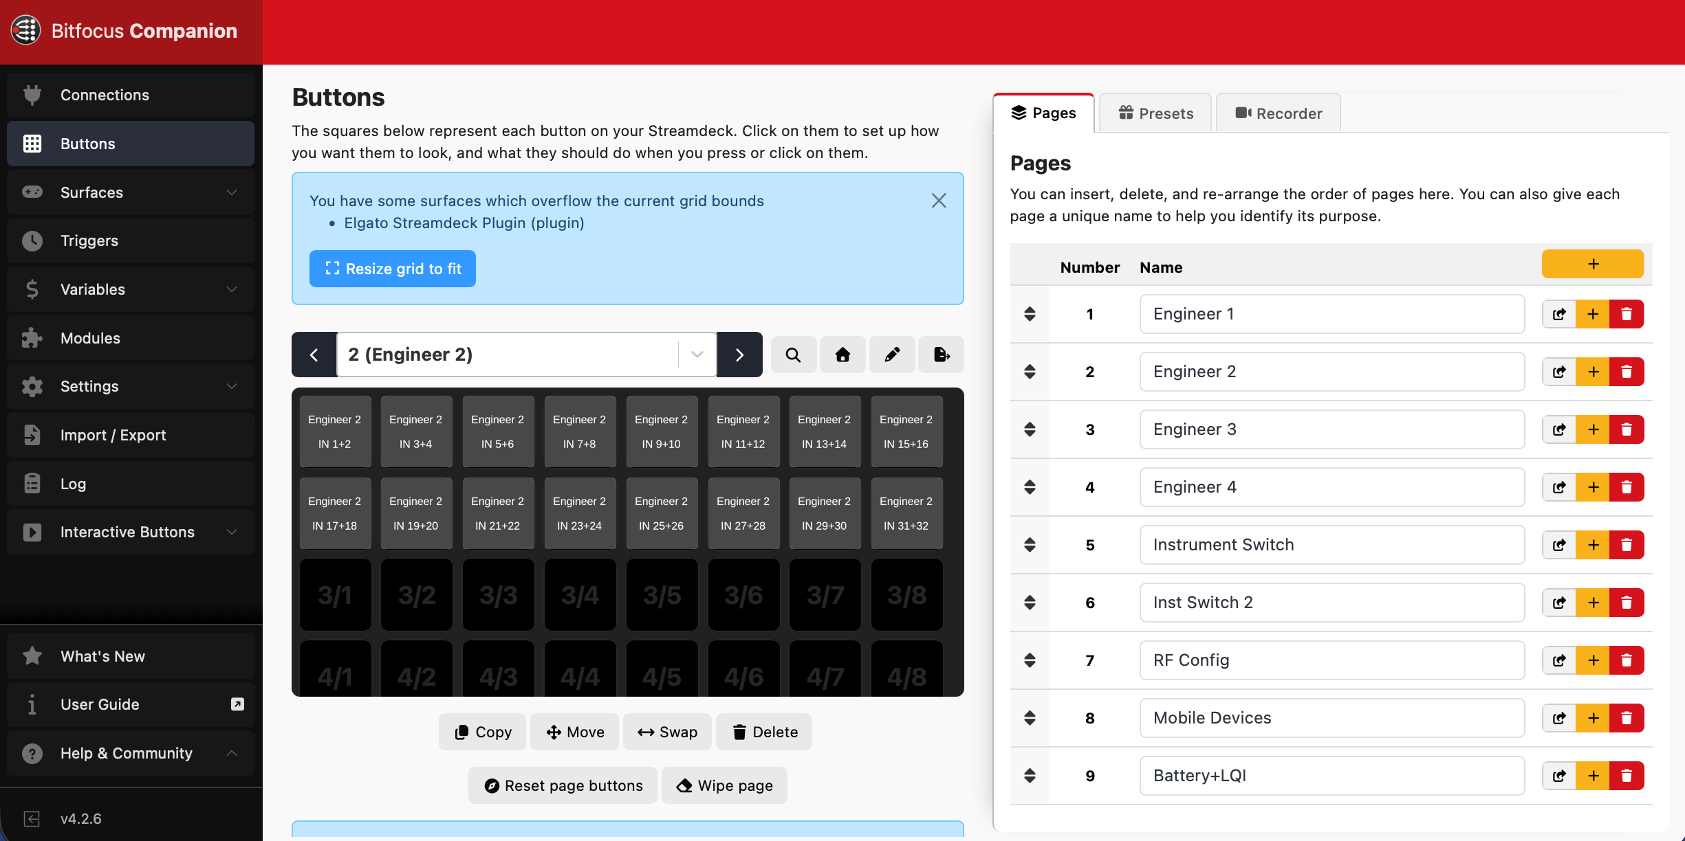
The Spectera module in Bitfocus Companion allows users to implement an engineer mode or switch the active guitar pack at the push of a button

“The Spectera integration allows users to introduce tactile control via stream-deck-style button panels or touchscreen panels and makes Spectera ready for interoperability with devices across different industries,” explains Greg Simon, Director, Technical Applications Engineering at Sennheiser. “I could now use a Spectera SEK to control lighting or have buttons on the console control Spectera, just as an example.”

The Spectera module in Bitfocus Companion and Buttons opens up Spectera to the many control workflows that already rely on these powerful tools, be it in AV applications, live show productions or places of worship.

(Ends)

The high-resolution images accompanying this media release can be downloaded here.

About the Sennheiser brand
We live and breathe audio. We are driven by the passion to create audio solutions that make a difference. Building the future of audio and bringing remarkable sound experiences to our customers – this is what the Sennheiser brand has represented for 80 years. While professional audio solutions such as microphones, meeting solutions, streaming technologies and monitoring systems are part of the business of Sennheiser electronic SE & Co. KG, the business with consumer devices such as headphones, soundbars and speech-enhanced hearables is operated by Sonova Holding AG under the license of Sennheiser.
www.sennheiser.com
www.sennheiser-hearing.com

Pro Audio Press Contact
Stephanie Schmidt
stephanie.schmidt@sennheiser.com
+49 5130 600-1275

